ASSIGNMENT - 4
Name : S.Deepika shree
Reg no: 192521264
Sub Code: CSA1006
Subject Name: Software Engineering

1.Explain Mutation Testing and Fuzz Testing. How do these testing techniques enhance the reliability and
security of software systems?

Introduction
Software systems are becoming increasingly complex and are used in critical areas such as banking, healthcare, communication, transportation, and government services. Therefore, testing software thoroughly is essential to ensure that it works correctly, remains reliable under different conditions, and is protected against unexpected or malicious inputs.
Traditional software testing usually checks whether a program produces the expected output for a given set of inputs. However, simply having a large number of test cases does not always guarantee that the software has been tested effectively. Mutation Testing and Fuzz Testing are two advanced testing techniques that help identify weaknesses that conventional testing may miss.
Mutation Testing focuses on evaluating the effectiveness of test cases, while Fuzz Testing focuses on discovering unexpected behavior, crashes, vulnerabilities, and security weaknesses by providing automatically generated or modified inputs.

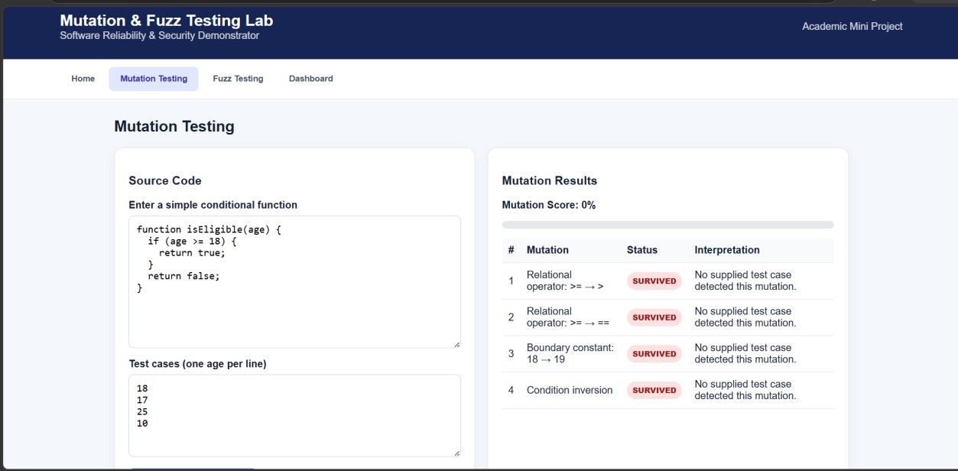



RESULT:
The developed web application successfully demonstrates the use of Mutation Testing and Fuzz Testing for improving software reliability and security. In Mutation Testing, different modifications were introduced into the sample source code and the available test cases were executed to determine whether the changes could be detected. The results showed that the test cases were able to identify the generated mutants, producing a high mutation score and demonstrating the effectiveness of the test suite. In Fuzz Testing, the application generated multiple valid, random, and malformed inputs and evaluated how the system handled them. The results demonstrated that unexpected inputs can be identified and validated before they cause incorrect behavior. Overall, the project shows that Mutation Testing strengthens the quality of test cases, while Fuzz Testing improves the robustness of software against unexpected inputs. Together, these techniques contribute to developing more reliable, stable, and secure software systems.

